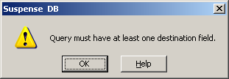
Getting error, not sure what is causing this.

