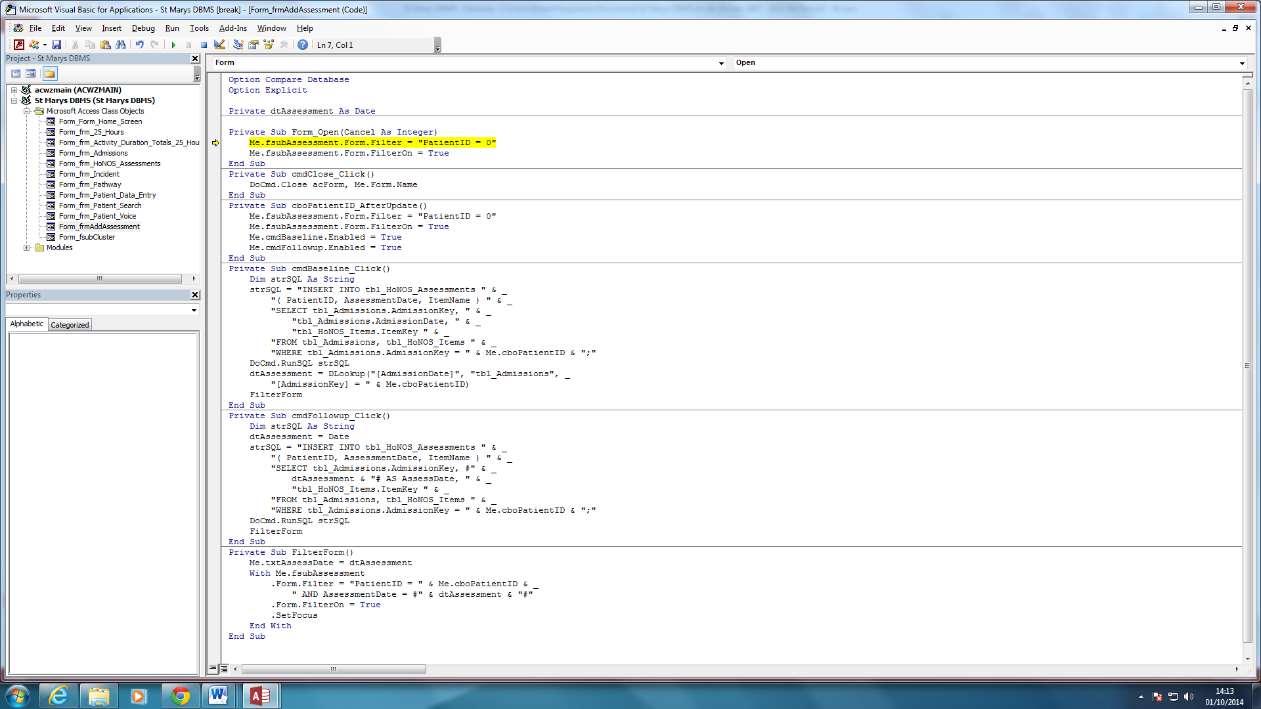

Is PatientID the index in your schema thereby needing changing to AdmisisonKey = 0 in mine? Just a thought but as PatientID uses AdmissionKey not sure its very helpful

